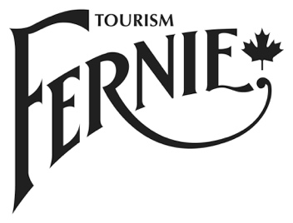
Tourism Fernie Co-operative Marketing Program Application

Application deadlines:
Spring/Summer initiatives are due April 30th, 2017
Fall/Winter initiatives are due July 31st, 2017 (note: initiatives must be completed by December 15th)

Submit questions and completed applications by email to: christine@tourismfernie.com

Only one submission allowed per intake periods. Applications will be reviewed by the Marketing Committee and funding notifications will be issued within 30 days. The designated Lead Applicant listed in the application will be notified of the funding decision.

Contact Information:

Lead Organization:
Member business/organization: | If this is a multi-member application, please list all partners.
Contact Person: | This person will act as the primary contact for the Application.
Mailing Address:
Telephone: |  | Email:

Application Proposal:

Name of Marketing Initiative: | Provide a name for the initiative.
Initiative Description: | Briefly describe the marketing initiative, including its purpose. How does the initiative complement and/or support the Tourism Fernie Strategic Plan (See Pg 3-4).
Objective(s): | List the objective(s) of your initiative. What specifically do you want to achieve?
Markets/Segments: | List the geographic and target markets you want to reach (must be inline with the Tourism Fernie Strategic Plan, see Pg 3-4).

For each tactic/activity, please list the following information:
- Tactic description (the specific marketing tactic(s) within the initiative/campaign)
- Approx. start & end dates. All initiatives must be completed before or by Dec 15th
- Metrics to track success
- Cost (not including GST)

Tactic # 1:
Tactic # 2
(if applicable)
Tactic # 3
(if applicable)

Budget Summary | Marketing Tactic Total Budget  Tactic 1 $  Tactic 2 $  Tactic 3 $  Tactic 4 $  Total: $
For Multi-Member Applications Funding Contributions: | List the member business/organizations that have committed funds to this project and specify the financial contribution from each organization.  Member #1:______________________ $ ___________  Member #2:______________________ $ ___________  Member #3:______________________ $ ___________  Member #4:______________________ $ ___________  Total: $ ___________  Cost-shared funding is available up to 50% of total budget. 10% will be held until the final report is received, due Dec 22nd.
Evaluation | Applicants are required to submit a report on the results and outcomes no later than December 22nd, 2017.  Report must include how the project objectives/tactic metrics (outlined earlier in your application) have been achieved, any learnings from the initiative and ideas on future initiatives. Report must include results such as impressions, readership, views, clicks, reach, distribution, etc. Report must also include samples or screenshots of the tactics.

